**Sustainable Supply Chain Performance Dashboard in Power BI**

**Week1 - REPORT**

**Step1: Install Power BI**

1. Download Power BI desktop: We can directly download from the Microsoft Store.
2. Install Power BI desktop: Once downloaded, open the installation file and accept the terms and conditions. Choose the installation folder and Click "Install” to complete the installation process.
3. Launch Power BI Desktop: Open the Power BI desktop and sign in with the Microsoft account.

**Step 2: Load the CSV File**

1.Save the CSV file: ensure your CSV file is saved on the system and easily accessible.

2.Import the CSV File into Power BI:

* Open Power BI Desktop.
* On the "Home" tab, click "Get Data" > "Text/CSV."
* Browse and select the desired CSV file.
* Click **"**Open" to load the file into Power BI. 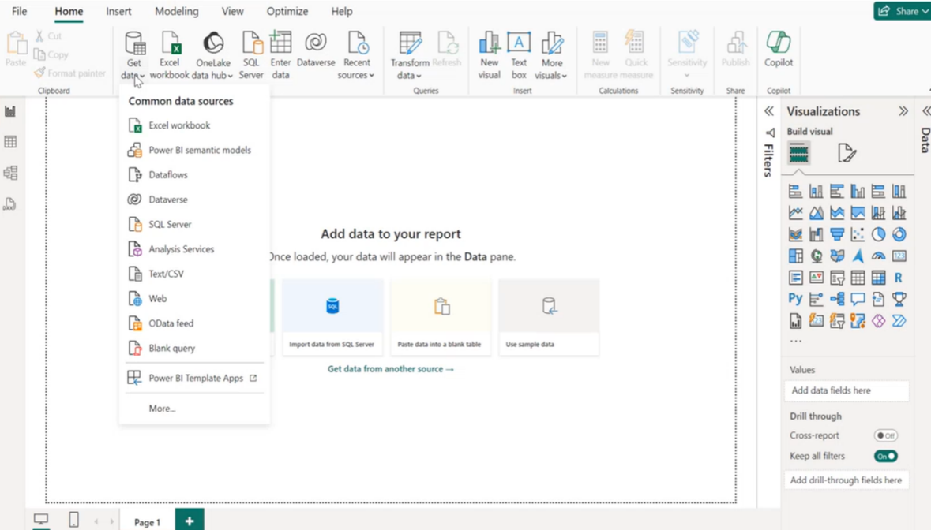

3.Preview the Data:

* A preview of the CSV data will appear.
* If the preview looks correct, click "Load" to add the data to Power BI.

**Step 3: Transform the Data**

1. Open Power Query Editor:

Click "Transform Data" in the Home tab. This will open the Power Query Editor. Then on the “view “tab, click the column quality.

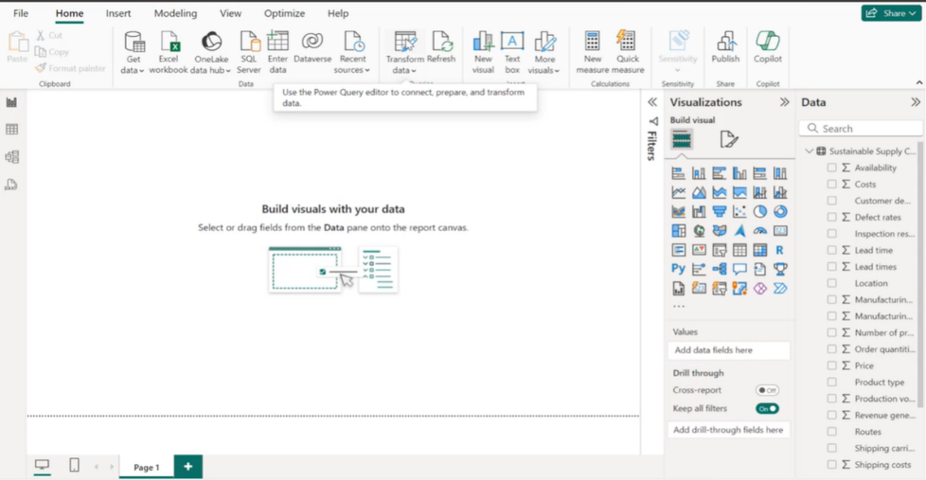

1. Examine the Data:

* In the Power Query Editor, review your data for errors, inconsistencies, or missing values.
* Examined that there are no missing values in the given dataset.

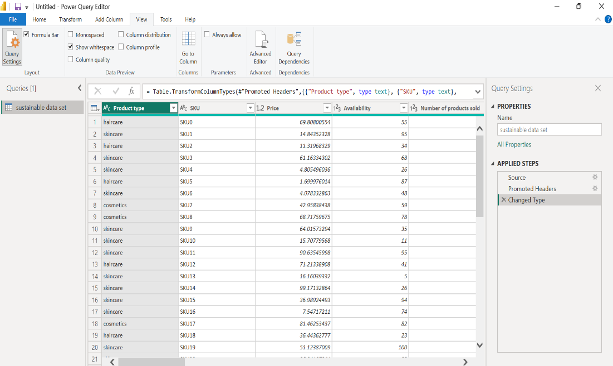

**Step 4: Duplicate the Original Table**

Right-click on the sustainable data set (original table -present in the Queries pane on the left) and Select "Duplicate."

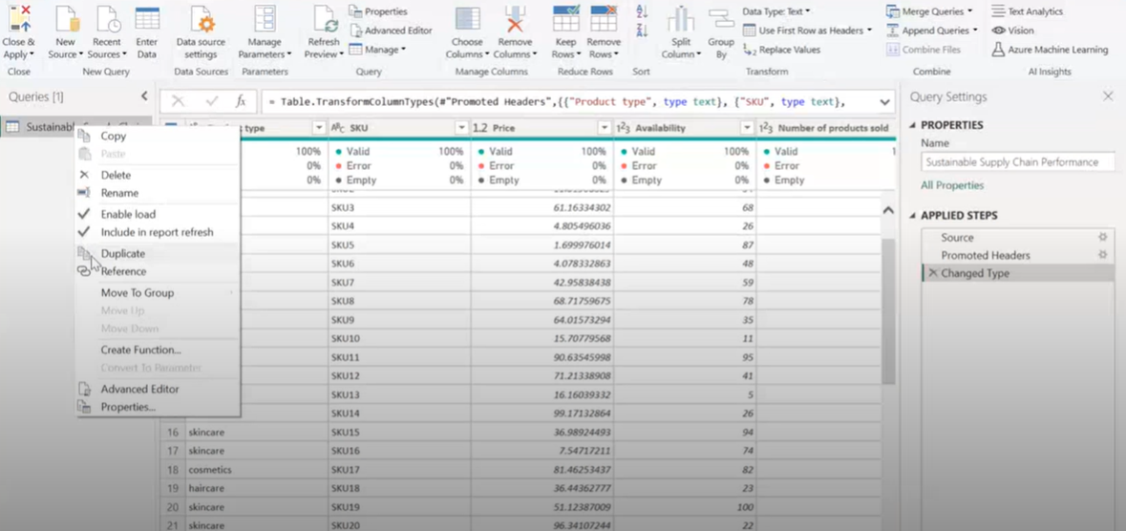

**Step 5: Rename the New Table**

1. Rename the Duplicated Table:

* Right-click the duplicated table and Select "Rename."
* Enter a new name for the table as “Inventory Table”

**Step 6: Remove Unwanted Columns**

1. Identify Unnecessary Columns**:** In the duplicated table, select columns that are not required.
2. Remove the Columns: Right-click the unwanted columns and choose "Remove Columns."

**Step 7: Repeat the Process for Other Tables**

1. Duplicate and Transform Other Tables**:** Same steps are followed to duplicate and rename the other tables (Manufacturing Table, Supplier table, supply chain table)
2. Consistency Check: Ensure all transformations align with the project's requirements.

**Step 8: Close and Apply**

1. Apply Changes:

* Once the process of transforming all the data tables is finished, click "Close & Apply" in the Power Query Editor.

1. Verify Changes:

* Ensure that new queries/tables have been added to the Fields pane in Power BI.

**Step 9: Save the File**

1. Save Power BI Project:

* Go to File > Save As.
* Choose a location and name the file.
* Save the file as a .pbix (Power BI file).

**Step 10: Upload to GitHub**

* Ensure your .pbix file is saved and finalized.
* Open your GitHub account. Click "Create Repository."
* In the new repository, click "Add file" > "Upload files."
* Drag and drop your .pbix file or select it from your system.
* Add a commit message (e.g., "Uploaded Power BI file").
* Click "Commit changes" to finalize the upload.